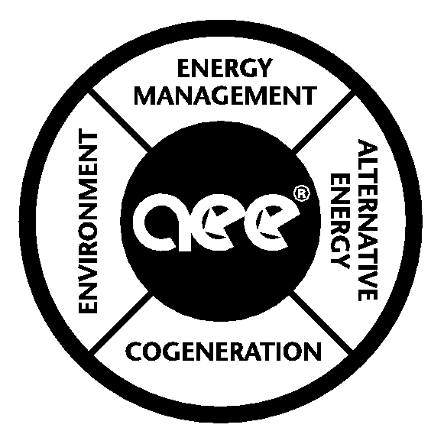
East Michigan
Association of
Energy Engineers

Winter 2012 Meeting:

Tuesday February 21, 2012 (note date changed from 2nd Tuesday for this meeting only)

MEETING LOCATION:
Alfred Taubman Student Service Center at Lawrence Technological University Rm C406

MEETING COST:
FREE for Chapter Members
Guests = $25
Students/Seniors =$19

AGENDA:
5:30 p.m. -- Social Time / Chapter Business
6:00 p.m. – Dinner
6:15 p.m. -- Presentation by Guest Lecturer with questions to follow

New Healthy, Airside Solutions to Significantly Reduce Your Carbon Footprint

By: Michael Leinweber, Sales Account Manager, Ingenuity IEO

Summary of presentation:
In the face of increasing energy costs and concerns over global warming, buildings are receiving increasing scrutiny to reduce their carbon footprint and cut their energy expenses. However, unlike in the 70’s, today’s buildings need to provide a healthy and comfortable indoor environment as well. Add to this the growing interest in making buildings green using the USGBC LEED (Leadership in Energy and Environmental Design) guidelines and what is a building owner to do?

A big part of the answer to this question revolves around how a building controls outside air since outside air is the largest single driver of both a building’s energy efficiency and its indoor environmental quality. In the past, such approaches as economizers and demand control ventilation have attempted to reduce energy expenses by controlling outside air but the actual results over time have been mixed at best.

This presentation will discuss a new, more energy efficient and healthier variation on demand control ventilation as well as how economizers can be operated more reliably with greater energy efficiency. The key to improving the operation of these outside air control approaches is a new, cost effective, and highly accurate sensing technology that will be discussed known as multiplexed sensing.

Additionally, a new approach for demand based control of air change rates in laboratory rooms will also be presented. This control approach can drop air change rates significantly when lab air is clean and increase it to higher, purge level rates when chemical vapors or particles are sensed in the room. This one approach has often been shown to be the single largest energy conservation measure safely applicable for many laboratory buildings.

Case study examples will also be presented of how this new technology is being employed.

Presenter Biography:

Michael Leinweber
Ingenuity IEQ

Michael Leinweber is a dynamic LEED accredited sales account manager for Ingenuity IEQ.

With 27 years of experience, he is an expert in construction management, business development and sustainable design. He has worked with a large variety of clients including owners, engineers, and architects to drastically improve critical airflow conditions while significantly reducing energy and maintenance costs. He is skilled in project management, architectural design and in developing innovative solutions to business problems.

Michael holds a Bachelor of Science degree in Architecture from the University of Michigan.

